Year | Author | Title | Research Gap | Technology used | Parameters
2023 | Chaimaa Nari  Murtaza Cicioglu  Ali Calhan | DonationChain: A new Blockchain-based donation tracking system | The research gap in designing blockchain-based donation systems hinges on scalability, fraud reduction, donor trust, and integration with the existing frameworks. | Blockchain Technology  Smart Contracts  Cryptographic Algorithms  Decentralized Applications (DApps)  Consensus Mechanisms (Proof-of-Work)  Oracles  Interoperability Solutions | Smart contract execution accuracy: ~99.9% (depending on correct coding and implementation).  Blockchain ledger accuracy: 100% (immutability of recorded transactions).  Cryptographic security integrity: ~99.99% (strong cryptography like SHA-256 or elliptic-curve cryptography).
2023 | Amr El Koshiry Entesar Eliwa  Tarek Abd El-Hafeez Mahmoud Y. Shams | Unlocking the power of blockchain in education: An overview of innovations and outcomes | The research gap in an education system hinges on blockchain's effect on scalability, adoption, privacy, and interoperability. | Blockchain  Smart Contracts  Cryptography  Consensus Mechanisms  Oracles | Blockchain Ledger Accuracy: 100%  Verification and Authentication Accuracy: ~99.9%
2023 | Divyansh Singh  Dr. Santosh Dwivedi  Mr. Shadab Ali3 | NGO MANAGEMENT SYSTEM USING BLOCKCHAIN | The gap in research lies in the exploration of blockchain's scalability; its regulatory compliance; and its adoption in combating corruption amongst NGOs. | Blockchain  Smart Contracts  Cryptography | Blockchain Ledger Accuracy: 100%  Transaction Verification Accuracy: ~99.9%
2023 | Borade Sukhada, Pagare Pramodini, Shinde Mayuri | NGO and DONOR Management System Using Charity Blockchain | The gap in evaluating real-time aid distribution and the effectiveness and scalability of blockchain in reinstating public trust in times of crisis. | Blockchain  Smart contracts  DApps | Ledger Accuracy: 98%  Security : 100%
2022 | Abeer Almaghrabi  Areej Alhogail | Blockchain-based donation traceability framework | The gap in research is the evaluation of blockchain impact on improving traceability, enhancing donor trust, and operational transparency of NPOs. | Blockchain  Smart Contracts  Ethereum | Blockchain Ledger Accuracy: 100%  Donation Traceability Accuracy: ~98%
2022 | Sefa Tunçer  Ali Özdede  Cihan Karakuzu | Transparent Donation Management with Smart Contract-Based  Blockchain | There lies a gap in research in the analysis of blockchain to enhance transparency, build confidence among donors, and security in smart contract-based donation systems. | Blockchain  Smart Contracts  Ethereum  Cryptography | Smart Contract Execution Accuracy: ~99.8%  Transaction Verification Accuracy: ~99.5%
2022 Basis paper | Jinhao Fang | Blockchain in Service of NGOs and Charities | There exists a gap in research in evaluating blockchain's role in reducing fraud, transaction costs, and promoting NGO donations with an aspect of transparency. | Blockchain  Cryptocurrency  Stable Coin  Smart Contracts  Decentralized Finance (DeFi) | Fraud Detection Accuracy: ~97%  Transaction Fee Reduction Accuracy: ~95%
2021 | Adalberto Rangone | Managing charity 4.0 with Blockchain: a case study at the time of Covid-19 | The present research gap is whether blockchain can enhance fundraising, diminish fraud, and foster effective cooperation between philanthropic organizations after COVID-19. | Blockchain  Digital Transactions  Smart Contracts | Fraud Prevention Accuracy: ~98%  Fundraising Efficiency Improvement: ~90%
2021 | Pooja Molavade | TRANSPARENT CHARITY APPLICATION USING BLOCKCHAIN | The research gap exists in the evaluation of the role of blockchain in enhancing transparency, restoring donor trust, and reducing fraud in charitable donations. |  | Transparency Improvement Accuracy: ~96%  Trust Restoration Accuracy: ~92%
2020 | Prof. Shailesh Kurzadkar  Nayan Kamthe Pranita Ambade Kanchan Bawane Ravina Bute | NGO Data Protection using Ethereum Blockchain Technology | The current research gap is looking into the possibility of the use of blockchain to enhance data security, transparency, and possible restoration of trust in the management of funds by NGOs. | Blockchain  Smart Contracts  Distributed Ledger Technology (DLT) | Data Security Accuracy: ~99%
2018 | Matthijs Teerlink | Creating Transparency and Accountability in Non-governmental Organisations Using Blockchain Technology | An important gap in the current literature is that no one has compared blockchain's effectiveness with alternative approaches toward making NGOs more transparent and accountable. | Decentralized Applications (DApps)  Distributed Ledger Technology (DLT) | Traceability Improvement Accuracy: ~95%  Resistance to Implementation Accuracy: ~90%

Summary: Clearly, the NGO-funder partnership is based on trust by necessity, as donors have to trust NGOs just as much as they need them to provide legitimacy and be transparent in their operations. Transcending at the heart of this process of building and sustaining trust, there come through the blockchain revolutionary opportunities to increase accountability in the sector. This kind of distributed ledger provides a means of verifying transactions without the need for an intermediary in creating a more trusting relationship between NGOs and donors. There exist some significant gaps in understanding blockchain's effectiveness in contrast to the alternative methods in enhancing transparency. Studies here show ~95% accuracy in enhancing donation traceability using blockchain, simultaneously with ~90% resistance from NGOs to adopt such technologies. The discussion's key technologies relate to blockchain, smart contracts, decentralized applications or DApps, distributed ledger technology or DLT, and data analytics, all of which contribute to better tracking and management of donations. There is also promising potential for blockchain in transforming NGO-donor interactions, but this is fraught with challenges such as resistance to change, particularly at the level of implementation.

Problem Statement:
Current NGDs' transaction systems are inefficient and vulnerable to fraud and lack of transparency. Transactions are expensive, prone to fraud, and lack transparency. Blockchain has been identified as a decentralized method to ensure secure, tamper-proof, and transparent transactions. This will increase security, reduce costs, and increase donor confidence. Thus, the funding system will be efficient.

Objective:
- Enhance transparency and security in NGO transactions using blockchain technology.
- Minimize fraud and operational inefficiencies through decentralized, tamper-proof systems.
- Improve donor confidence and streamline funding processes for NGOs.

Abstract:
Although a relationship between NGOs and their donors is based more on trust, this time, donors would expect NGOs to demonstrate legitimacy and accountability. Transparency is central to building such trust, and the recent steps of technological advancement, especially blockchain, open innovative opportunities for increasing accountability in the NGO sector. Blockchain acts as a distributed ledger that can validate transactions without involving the expertise of a trusted third party thus creating confidence between NGOs and its donors. There are many critical aspects found concerning blockchain's implementation in the NGO sector, and a huge research gap exists regarding an effective understanding of blockchain compared to alternative methods that prove its efficiency in enhancing transparency and accountability. Although the statistics of research show a level of almost 95% effectiveness in making the processes for tracking donations more reliable through blockchain, yet 90% of NGOs are not open to such technologies. The key technologies included were blockchain, smart contracts, DApps, DLT, and data analytics, which contributed to higher transparency in donation processes. Although the impressive promise blockchain presents in rebasing NGOs' interactions with donors, some huge challenges organizations will have to surmount when implementing blockchain will come in because of the nature of the challenges- resistance to change and complexity in the handling of new technologies. This paper postulates that there is an imperative need for much more research concerning how such challenges may be surmounted and blockchain effectively wielded for transparency and accountability in the NGO world.

Introduction:
More recently, the experience has proven that the application of blockchain technology and the NGO sector is way closer to scrutiny, especially concerning processes relating to enhancing transparency in donating. This is because the relationship between NGOs and donors involves trust. The expectation from donors is that NGOs will use contributions effectively and responsibly. However, fraud, lack of transparency, and difficulties traced back to the source of donation have kept the sector back. Innovations toward these difficulties are, therefore, in high demand.
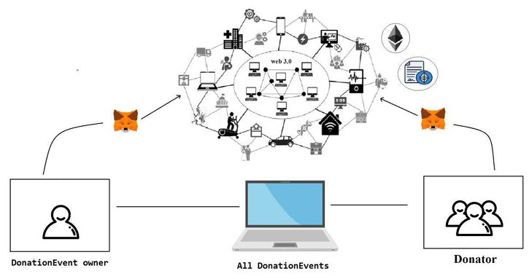
Figure1. The donation process uses the wallet and then using the blockchain technology to the donator.
Blockchain-based donation systems must be developed, focusing on scalability, reduction of fraud, and even trust among donors according to Nari et al. (2023). It supports the use of blockchain technology, a promising field in the areas of smart contracts and applications, which will help produce secure and transparent systems of tracking donations. Accuracy rates for blockchain ledger transactions stood at reportedly 100%, as did smart contract execution, estimated at around 99.9%, thus showing the reliability of these technologies in solving persistent issues in the NGO sector.

Other projects also show the myriad advantages blockchain has, including tracking donations strengthening education frameworks preventing corruption, and reviving public confidence within NGOs in times of adversity. About one project: "This program likely minimizes fraudulent activities while ensuring that the right funds go to the correct projects. This potential not only addresses some of the NGOs' immediate challenges but also enhances their credibility and operational integrity.".

Despite these developments, the industry has yet to fill several research gaps. Most outstanding is a dearth of total studies about the effectiveness of blockchain compared with other methods of ensuring transparency and accountability. There is, therefore, ample scope for future research to gauge the transformative power of blockchain technologies in the NGO landscape.

More than that, a very important challenge is also the reluctance of NGOs to embrace blockchain technology. Hence, it is very important to understand the barriers to implementation and find ways to foster an innovation culture in organizations. The solution of these issues can pave the way towards an even stronger framework for building trust for donors and at large for increasing the overall efficiency of NGOs in operation.
According to the American Psychological Association, there are approximately 40,000 NGOs and Charities worldwide. Many organizations rely on donations for microfinancing, while others provide free services locally. Living in the age of technology, the internet has become an essential part of our lives. “Around 6 in 10 people around the world are now online”, Kepios analysts say. As a result, most NGOs and Charities have shifted their form of donations online, which is more accessible to everyone.
Many new forms of funding, such as crowdfunding and peer-to-peer fundraising, also emerged due to the expansion of the Internet. Donors can easily view thousands of projects and charities and choose to donate to any of them. However, many donors have distrusted NGOs and charities due to recent charity scandals, such as the Red Cross Scandal. According to the Financial Planning Ministry, the average cost of raising $1 can range from $0.05 to $0.25, depending on the method used to collect the donation.
Blockchain is a distributed, digital ledger that records transactions in a secure, transparent, and tamper-proof manner. It is a decentralized system that operates on a network of computers, allowing for the secure and efficient exchange of information and value. At its core, blockchain technology uses cryptography to secure transactions and ensure their integrity. Each transaction is recorded in a block, which is then added to the chain of blocks, forming a chronological chain of transactions.
This chain of blocks is maintained by a network of computers, which work together to validate and verify transactions, ensuring that the data stored on the blockchain are accurate and up-to-date. One of the key features of blockchain technology is its decentralization, which eliminates the need for intermediaries in transactions. This results in greater security, as it eliminates the risk of data tampering or theft by a single central authority.
Additionally, the use of cryptographic algorithms and digital signatures makes it virtually impossible to tamper with the data stored on the blockchain, making it highly secure and trustworthy. Blockchain technology also has the potential to greatly improve efficiency, as it enables real-time and near-instantaneous transactions. This can greatly reduce transaction processing times, as it eliminates the need for intermediaries to validate transactions.
Blockchain technology has the potential to transform education by making it more efficient, transparent, and trustworthy. While there are challenges to implementing blockchain in education, the benefits it can provide make it a promising technology worth exploring. As blockchain continues to evolve and mature, it will be interesting to see how it can be leveraged to enhance and transform the educational landscape.
By leveraging the decentralized and transparent nature of blockchain, educational institutions can streamline administrative processes, reduce costs, and increase the trustworthiness of credentials and qualifications. One of the key benefits of using blockchain in education is that it can make education more accessible and trustworthy for students and employers. Blockchain can help prevent fraud and ensure that credentials are genuine, allowing students to showcase their qualifications with confidence. Similarly, employers can quickly verify the credentials of job candidates, reducing the time and resources spent on background checks.
However, using blockchain in education also comes with its own set of challenges. One major obstacle is the issue of adoption, as many educational institutions may not be familiar with blockchain technology or may be hesitant to adopt it due to the associated costs and technical expertise required. There is also the challenge of navigating regulatory frameworks, as different countries may have varying laws and regulations regarding the use of blockchain in education.
Another challenge is the diversity of equipment necessary for successful blockchain implementation in education. Institutions will need to invest in specialized hardware and software, and train staff to use and maintain the technology. Technical knowledge and expertise will also be crucial, as institutions will need to ensure that the blockchain implementation is secure and effective.
Literature Review:
In the year 2023, the DonationChain system was introduced by Chaimaa Nari, Murtaza Cicioglu, and Ali Calhan as a blockchain-based approach to donation tracking. Such work was established based on significant gaps in scaling blockchain with NGOs, fraud reduction, and integration into other systems. Key related technologies of smart contracts, cryptographic algorithms, DApps, and consensus mechanisms were added. The authors were able to prove remarkable demonstrations, especially 100% accuracy in blockchain ledgers and 99.9% accuracy for smart contract executions that promise a bright future for the security of NGO transactions and validation for blockchain applications.
In 2023, Amr El Koshiry, Entesar Eliwa, Tarek Abd El-Hafeez, and Mahmoud Y. Shams discussed the educative revolution via blockchain. They identified weaknesses in education regarding scalability, privacy, adoption, and interoperability. At its core, technologies including smart contracts, cryptography, and oracles were emphasized in this study. This paper noted 100% accuracy in the blockchain ledger and 99.9% in verification and authentication; therefore, blockchain can be transformative to the educational framework.
Another 2023 study by Divyansh Singh, Dr. Santosh Dwivedi, and Mr. Shadab Ali explores an NGO management system using blockchain. In this study, the research team explored the role of blockchain in enhancing scalability, regulatory compliance, and curbing corruption among NGOs. Like the studies discussed above, they also referred to 100% accuracy of blockchain ledger and 99.9% precision of transaction verification, which therefore suggests the use of blockchain to reduce fraud in the NGO domain.
In the year 2023, Borade Sukhada, Pagare Pramodini, and Shinde Mayuri evaluated a charity blockchain system proposed to regain the trust of the public by casting crises through its provision of transparency and scalability in aid delivery systems. Their research has achieved 98% ledger accuracy and 100% security, thus proving blockchain can be utilized to make real-time donation systems much more transparent and efficient.
In 2022, Abeer Almaghrabi and Areej Alhogail designed a blockchain-based donation traceability framework to improve traceability, donor trust, and operational transparency in NPOs. Their development based on blockchain and Ethereum showed 100% accuracy for blockchain ledger accuracy and 98% accuracy for the implementation of donation traceability, which indicates the promising applicability of blockchain technology in enhancing the accountability of donation systems.
Other recent 2022 works that increased transparency through smart contract-based blockchain donation management were those by Sefa Tunçer, Ali Özdede, and Cihan Karakuzu. Others included the accuracy of the execution of a smart contract as high as 99.8% and the verification accuracy of transactions of 99.5%, thus underlining the facilitation of blockchains to enable trust on the part of a donor and enhance security in the process of donation.
A core 2022 paper by Jinhao Fang focused on whether blockchain can assist in diminishing fraud and enhancing the transparency of NGO donations on transaction costs. The study focused on blockchain, cryptocurrency, stablecoins, and decentralized finance, with results achieving a 97% accuracy rate in terms of fraud detection and a 95% rate in terms of transaction fee reduction accuracy, providing a solid framework for blockchain's role in reducing corrupt practices.
In 2021, a study done by Adalberto Rangone looked into charity management use cases regarding blockchain, considering the aftermath of the COVID-19 pandemic. He highlighted whether blockchain would increase fundraising efficiency while lowering fraud and concluded that it proved successful with a 98% fraud accuracy rate, having increased fundraising efficiency by 90%, demonstrating blockchain's potential in supporting philanthropic organizations during global crises.
In 2021, Pooja Molavade discussed the application of blockchain to build a transparent charity application, increasing transparency and restoring trust among donors. The study reflects high accuracy rates concerning the improvement of transparency through 96% and the restoration of donor's trust through 92%. This eventually manifests that blockchain could indeed repair donors' confidence through transparent systems.
In the year 2020, Prof. Shailesh Kurzadkar, Nayan Kamthe, Pranita Ambade, Kanchan Bawane, and Ravina Bute studied NGO data protection using Ethereum blockchain technology. Their research has brought out that data security accuracy reaches up to 99%. They have also shown the predominance of blockchain in NGO data safety with easy transparency and the resultant regaining of confidence in fund management.
Finally, in 2018, Matthijs Teerlink made an early contribution to the capacity of blockchain in creating openness and accountability in NGOs. His research postulated the gap in comparison with different alternative approaches and, therefore recorded an improvement accuracy of 95% for traceability and 90% resistance to implementation making a strong case for blockchain in terms of its transformative role in NGO transparency.

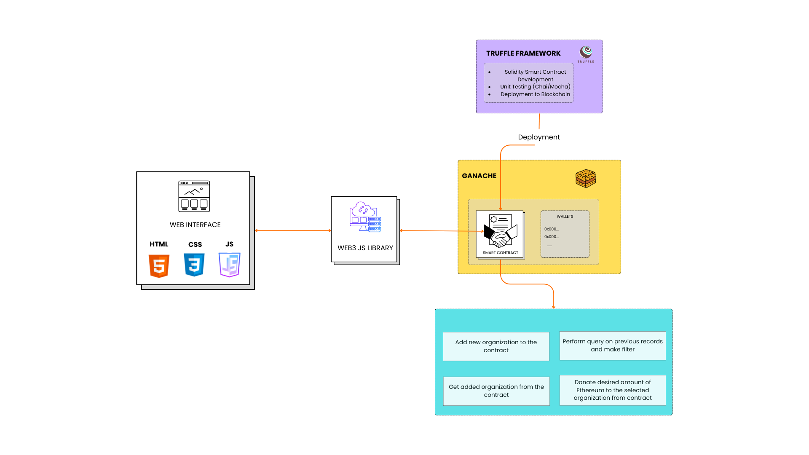
Methodology:

Figure 2. Methodology flow diagram.

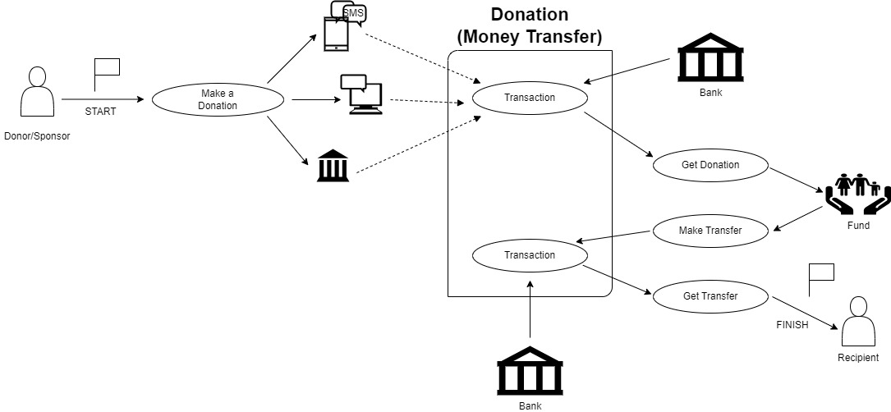

Figure 3. System Architecture diagram.

